Longview Chapel Parents Day Out/Preschool
2026-27 ENROLLMENT FORM
850 SW Longview Road, Lee’s Summit, MO 64081
longviewchapelcc.org
816-763-8074 pdo@longviewchapelcc.org

Child’s Name___________________________________________________________
Enrollment/Supply Fee: A non-refundable enrollment/supply fee of $125 is required at the time of enrollment. If you have more than one child, the enrollment fee is $240. * Please note that children will not be enrolled in our program until all paperwork has been submitted along with your child’s immunization records and enrollment fees.
Please Check (√) | Class | Eligibility | Monthly Tuition
 | Bears (PreK) | Must turn 4 years old by July 31, 2025 | $275
 | Tigers | Must turn 3 years old by July 31, 2025 | $275
 | Lions  (Potty training not required) | Must turn 2 years old by July 31, 2025 | $300

Longview Chapel Preschool has permission to make my address, phone number, and/or email address available to other parents. (circle) YES/NO

Immunizations

We must have a current copy of your child’s immunizations on file. According to state regulations, each child in our program must comply with the immunization schedule stated by the Department of Health. This schedule calls for a child who is 16 months through 59 months of age to have the following doses of vaccines: 4 DTaP, 3 IPV, 3 Hib, 3 Hep B, 4 PCV, 1 MMR, and 1 Varicella (or proof of chicken pox). Once your child’s record is in our office, you need not duplicate it. If your child receives any additional vaccinations, please bring us a current (new) copy of their immunizations for our records.
Physical
The State of Missouri also requires that each child enrolled in our program have a physical assessment form signed by a doctor or advanced practice nurse on file. The physician’s assessment can be completed up to 12 months prior to admission to school.
No child will be allowed to enter school without an updated immunization record and a doctor’s signed physical assessment form on file.

Field-Trip/Activity Fee:
Longview Chapel Preschool requires a $50 activity fee/Fieldtrip fee per child enrolled in our program. Please pay the activity fee by cash or check and turn in by the first day of school. The activity fee provides admission for your preschooler plus one adult to attend field trips as well as funding for various preschool events and class parties throughout the year. Additional family members who wish to attend the field trips will be able to purchase tickets separately at each location. This fee will not be discounted for multiple children or other circumstances without prior approval.

Pick-up Authorization

If a child is to go home with someone other than his/her parent or guardian, we must have a pick-up authorization form on file giving written permission for your child to be released to this person. We will allow no exceptions concerning the release of a child to someone not authorized in our files.

Child’s Name: _________________________________________________ Date: ____________________

Please list any person(s), other than parents, that would be authorized to pick up your child from Longview Chapel Preschool/PDO:
Name of Pick-up Person Relationship to Child Telephone
______________________________________________________________________________________
______________________________________________________________________________________
______________________________________________________________________________________
______________________________________________________________________________________
Thank you for your cooperation. Our main focus is the safety and well-being of our students.

______________________________________________________________________________________
Parent/Guardian Signature Date

Immunization Notice
This is a state form that must be signed by a parent or guardian. Longview Chapel Preschool requires that all children enrolled at Longview Chapel Preschool must be up to date on all immunizations according to their age or be in the process of receiving all immunizations. If your child is in the process of receiving immunizations, we require a doctor’s note stating the reason for the delay and an updated schedule on when vaccinations will be received. If the child fails to receive vaccinations as indicated, they may be asked to leave the program.

In accordance with Section 210.003.7, RSMo., the parent or guardian of a child enrolled or attending Longview Chapel Preschool may request notice of whether there are any children enrolled at our facility with an immunization exemption on file. If you would like to request this information, please contact Whitney Mammoliti and the information will be provided to you. Please note, the name or names of individual children are confidential and will not be released. Our response will be limited to whether there are children enrolled at our facility with an immunization exemption on file.

______________________________________________________________________________________
Parent/Guardian Signature Date
Picture/Video Release

During the school year, we will be taking photographs and/or videos of your child for classroom projects and the Longview Chapel Preschool Website.
Please select:

_________ My child’s picture/video/likeness may be used for classroom projects, church newsletter, and the website.

_________ My child’s picture/video/likeness may be used for classroom projects only.

_____________________________________________________________________________________
Parent/Guardian Signature Date

Allergy/Snack Consent
Generally, each student should bring their own snack and lunch each day. Occasionally, they could be given snacks that are brought in by teachers or different classmates. We have children that have many different forms of allergies. If your child has any food allergies or sensitivities, please provide us with information regarding your child’s dietary restrictions and potential reactions. If you do not want them eating the snacks brought in by teachers or classmates, please provide a snack for your child.
If you do choose for your child to eat the snacks provided, please sign below giving your permission. Your child’s health and welfare are our priority.

My child, ______________________________________________, may eat the snacks brought into Longview Chapel Preschool/PDO by teachers or other children. I understand that if I do not want my child to eat the snacks provided, I may bring in a snack for my child.

______________________________________________________________________________________
Parent/Guardian Signature Date

*A 30 day written notice must be given if your child will be exiting the program. You are responsible for the tuition during this time.*

Field Trip Permission Slip

Sometimes we have rainy days and some very cold days. I have permission from the state to use the upstairs “Long Hall” for an indoor recess room and other whole group activities. All that is required is a field trip permission slip form!

We sometimes use the “Old Fellowship Hall” in the church basement for gymnastics class and other group activities, and this area requires a field trip permission slip.

We have the ability use the “Old Kitchen” in the church basement for class projects and other group activities, and this area also requires a field trip permission slip.

My child, __________________________________________, has permission to use the upstairs “Long Hall,” the downstairs “Old Fellowship Hall,” and the “Old Kitchen” for group activities.

______________________________________________________________________________________
Parent/Guardian Signature Date

Gym Class Permission Slip

Once a week, our students can participate in a gross motor movement class that includes some gymnastics activities and other exercises designed to help our students work on their gross motor development (and help get some of our wiggles out). This gross motor movement class sometimes uses gymnastics equipment during that class.

My child, __________________________________________, has permission to participate in the gross motor movement class, gymnastics activities, and use gymnastics equipment during that class.

______________________________________________________________________________________
Parent/Guardian Signature Date

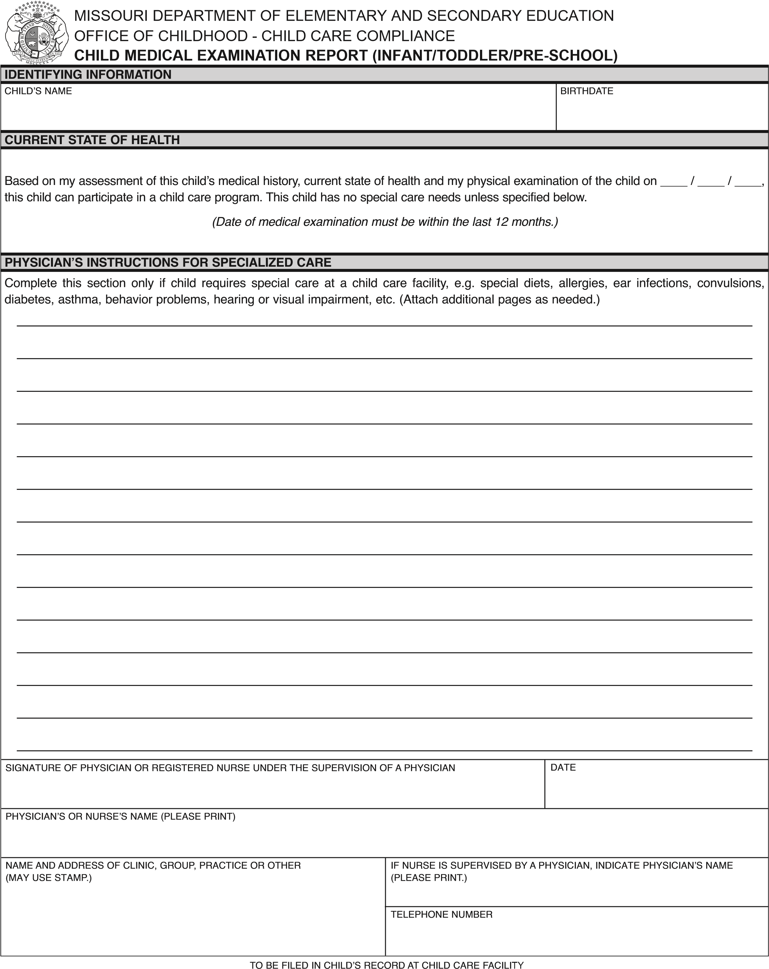

 | MISSOURI DEPARTMENT OF ELEMENTARY AND SECONDARY EDUCATION  OFFICE OF CHILDHOOD - CHILD CARE COMPLIANCE  CHILD CARE ENROLLMENT FORM FOR LICENSE-EXEMPT FACILITIES
FACILITY/PROVIDER NAME |  |  | ADMISSION DATE |  |  |  |  | DISCHARGE DATE
CHILD’S NAME |  |  | GENDER |  |  |  |  | BIRTHDATE
ADDRESS (STREET, CITY, STATE, ZIP CODE)
IDENTIFYING INFORMATION
MOTHER’S/GUARDIAN’S NAME |  |  |  |  |  | HOME TELEPHONE NUMBER
ADDRESS (STREET, CITY, STATE, ZIP CODE) OR CHECK IF SAME AS ABOVE |  |  |  |  |  | CELL PHONE NUMBER
E-MAIL ADDRESS
EMPLOYER OR SCHOOL ATTEND |  |  |  |  |  | WORK/SCHOOL SCHEDULE
EMPLOYER/SCHOOL ADDRESS (STREET, CITY, STATE, ZIP CODE) |  |  |  |  |  | WORK TELEPHONE NUMBER
FATHER’S/GUARDIAN’S NAME |  |  |  |  |  | HOME TELEPHONE NUMBER
ADDRESS (STREET, CITY, STATE, ZIP CODE) OR CHECK IF SAME AS ABOVE |  |  |  |  |  | CELL PHONE NUMBER
E-MAIL ADDRESS
EMPLOYER OR SCHOOL ATTEND |  |  |  |  |  | WORK/SCHOOL SCHEDULE
EMPLOYER/SCHOOL ADDRESS (STREET, CITY, STATE, ZIP CODE) |  |  |  |  |  | WORK TELEPHONE NUMBER
EMERGENCY CONTACT AND PERSONS AUTHORIZED TO TAKE CHILD FROM FACILITY (OTHER THAN PARENT) AT LEAST ONE EMERGENCY CONTACT IS REQUIRED.
NAME |  | RELATIONSHIP TO CHILD |  |  |  |  | TELEPHONE NUMBERS (CELL, WORK, HOME)
ADDRESS (STREET, CITY, STATE, ZIP CODE)
NAME |  | RELATIONSHIP TO CHILD |  |  |  |  | TELEPHONE NUMBERS (CELL, WORK, HOME)
ADDRESS (STREET, CITY, STATE, ZIP CODE)
AUTHORIZATION FOR EMERGENCY MEDICAL CARE
I UNDERSTAND THAT I WILL BE NOTIFIED AT ONCE IN CASE OF AN EMERGENCY WITH MY CHILD, AND I WILL MAKE ARRANGEMENTS FOR MEDICAL CARE OF MY CHILD WITH THE PHYSICIAN OR HOSPITAL OF MY CHOICE.
IF I CANNOT BE REACHED TO MAKE NECESSARY ARRANGEMENTS, OR IN A CRITICAL EMERGENCY REQUIRING MEDICAL CARE, I AUTHORIZE
DAY CARE PROVIDER TO CONTACT THE FOLLOWING:
PHYSICIAN OR CLINIC
NAME |  |  |  |  |  |  | TELEPHONE NUMBER
PREFERRED HOSPITAL
NAME |  |  |  |  |  |  | TELEPHONE NUMBER

